Name of participant (if you wish): _________________________________

This is a quick survey to say if you are happy with the service you are getting.

“I am happy with the service I get from Kyeema” (circle one option):
Yes  No 
If you are happy and do not want to say anything further, you may stop here and return the survey. Thanks!

Any comments?

If you wish to continue please do. Also, if you are not happy then we invite you to continue with the survey so we can improve.
If you have a problem with Kyeema would you speak up about it? | Yes | No
Do you feel your goals and needs are listened to? | Yes | No

Any further comments?

Do you need to speak to a Kyeema manager or community advocate about something now? | Yes | No

If yes, please write your name and contact phone number and a community advocate will call you.

Name: ______________________ Contact phone number: _____________


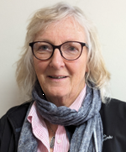
Community Advocates:
Iain McDonald
Jen
Merrett

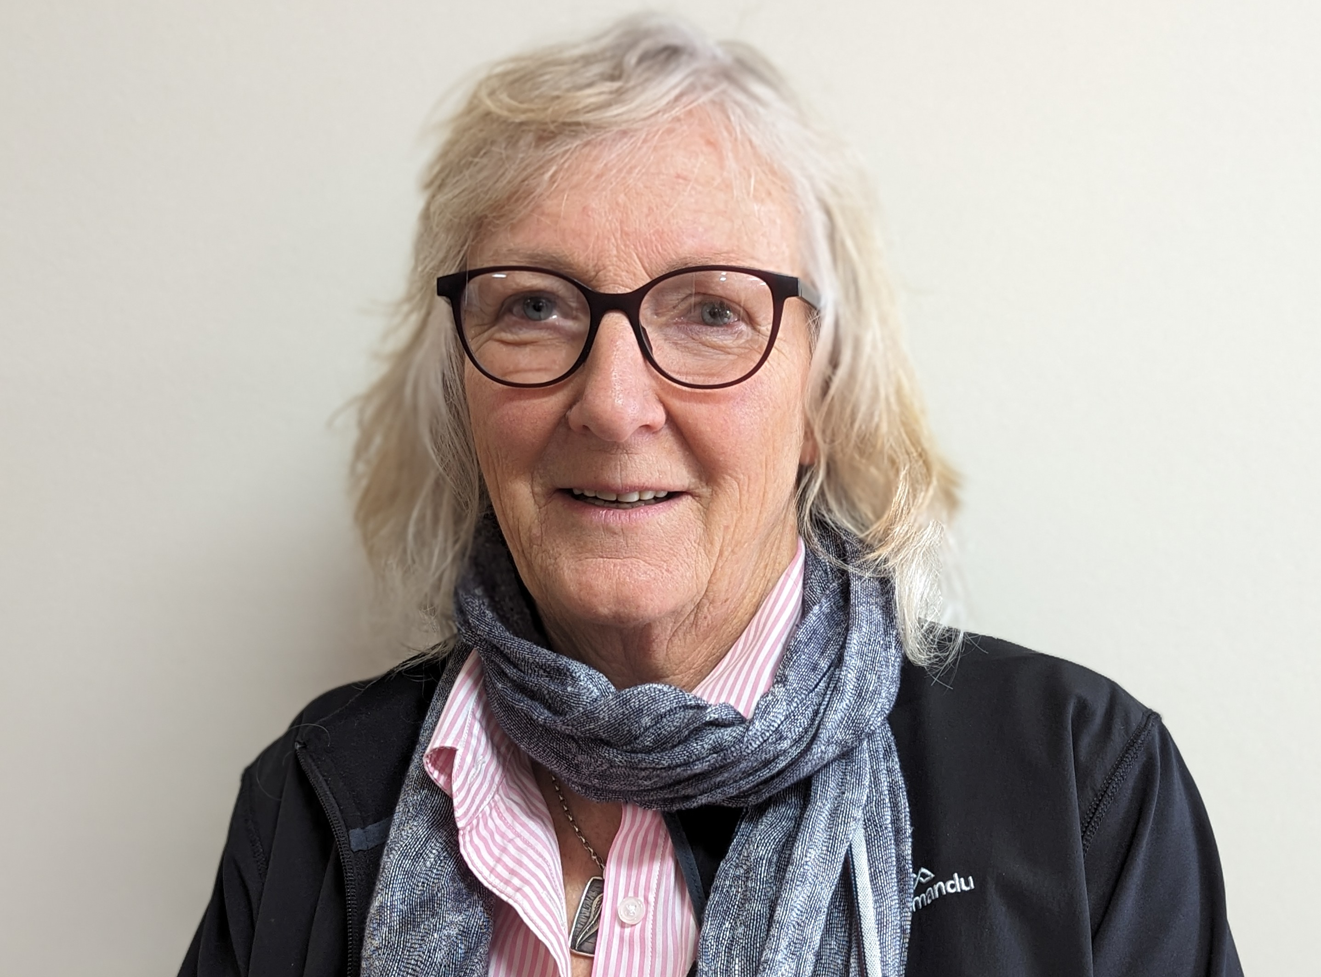

These surveys go to the Community Advocates

